* **INVERSE OF A MATRIX USING MINORS, COFACTORS AND ADJUGATE**
* We can calculate the Inverse of matrix by:
* Step 1: calculating the Matrix of Minors,
* Step 2: then turn that into the Matrix of Cofactors,
* Step 3: then the Adjugate, and
* Step 4: multiply that by 1/Determinant.

But it is best explained by working through an example!

* **Example: find the Inverse of A:**

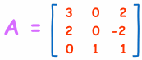

It needs 4 steps. It is all simple arithmetic but there is a lot of it, so try not to make a mistake!

* **Step 1: Matrix of Minors**

The first step is to create a "Matrix of Minors". This step has the most calculations.

For each element of the matrix:

* Ignore the values on the current row and column
* Calculate the determinant of the remaining values

Put those determinants into a matrix (the "Matrix of Minors")

* **DETERMINANT**
* For a 2×2 matrix (2 rows and 2 columns) the determinant is easy: **ad-bc**

|  |  |  |
| --- | --- | --- |
| Think of a cross:   * Blue means positive (+ad), * Red means negative (-bc) |  | A Matrix |

(It gets harder for a 3×3 matrix, etc)

* **The Calculations**

Here are the first two, and last two, calculations of the "**Matrix of Minors**" (notice how I ignore the values in the current row and columns, and calculate the determinant using the remaining values):

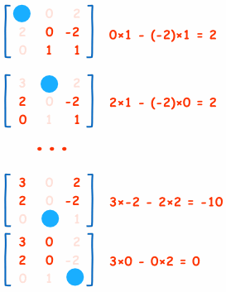

And here is the calculation for the whole matrix:

* **Step 2: Matrix of Cofactors**

This is easy! Just apply a "checkerboard" of minuses to the "Matrix of Minors". In other words, we need to change the sign of alternate cells.

* **Step 3: Adjugate (also called Adjoint)**

Now "Transpose" all elements of the previous matrix... in other words swap their positions over the diagonal (the diagonal stays the same):

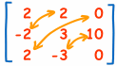

* **Step 4: Multiply by 1/Determinant**

Now find the determinant of the original matrix. This isn't too hard, because we already calculated the determinants of the smaller parts when we did "Matrix of Minors".

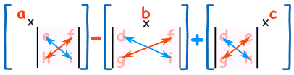

* In practice we can just multiply each of the top row elements by the cofactor for the same location:

Elements of top row: 3, 0, 2  
Cofactors for top row: 2, −2, 2

Determinant = 3×2 + 0×(−2) + 2×2 = **10**

(Just for fun: try this for any other row or column, they should also get 10.)

And now multiply the Adjoint by 1/Determinant:

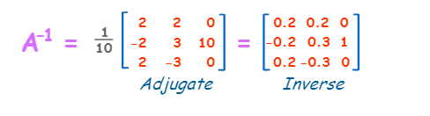

And we are done!